**VMOSA (Vision, Mission, Objectives, Strategy, Action Plan)**

***Vision***

5 to 10 years span (To where you want to reach)

***Tesla Motors Vision Statement***

To create the **(most compelling) (car company)** of the **(21st century)** by driving **(the world’s transition to electric vehicles)**.

* They are clearing it that they are car company and there all focus is to make great cars.
* They will do it in 21st Century.
* To shift whole world to electric motors.

***Microsoft Vision Statement***

To **(help)** **(individuals)** and **(businesses)** **(realize)** their **(full potential)**.

* They cleared it that they are dealing with individuals as well as Business Customers.
* Help Realize is that they are making it clear that they will put in all energy in it.
* They want to unlock your potential their product is just for assistance.

***Amazon Vision Statement***

Our vision is to be **(earth's)** most **(customer-centric)** company; to build a place where people can come to find and discover **(anything they might want to buy online)**.

* Global Reach, Whole world is there customer.
* Customer Prioritization.
* Widest Selection of product.

***Intel Vision Statement***

If it’s (**smart and connected)**, (**its best with Intel)**.

* They are clearing it that everything is around smart and connected.
* Nobody is better than Intel.

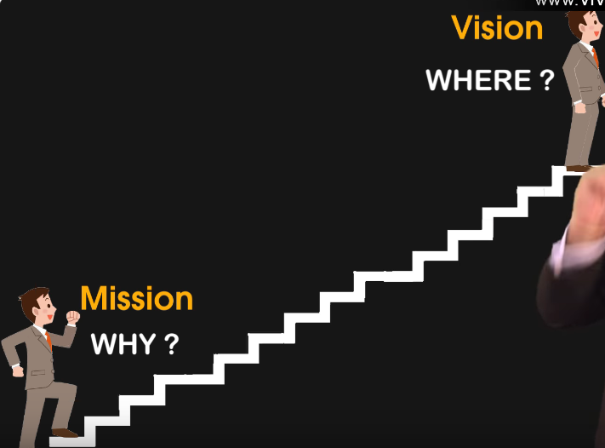

***Mission***

Starting point (Why you want to reach there, why you exist, purpose)

* Purpose is which problem of your customer you are solving.
* Profit is not mission it’s just an outcome.

***Tesla Motors Mission Statement***

To **(accelerate)** the world’s transition to **(sustainable energy)**.

* They do it with speed.
* To eliminate Diesel and Petrol cars.
* To shift world to electrical motors.

***Google Mission Statement***

Organizing the world’s information.

* To bring world’s all information to you.
* They could have said we are the best search tool.
* They need to work hard at backhand to organize world’s all data just to bring it to you.

***Amazon Mission Statement***

We strive to offer our customers the **(lowest possible prices)**, the **(best available selection)**, and the **(utmost convenience)**.

* Lowest price for customer.
* Everything available.
* Most convenient home service.

***Nike Mission Statement***

To bring inspiration and innovation for every athlete in the world.

* Always innovating.
* Always inspiring.
* Every athlete.
* Nike always stands for athletes (Steve jobs).

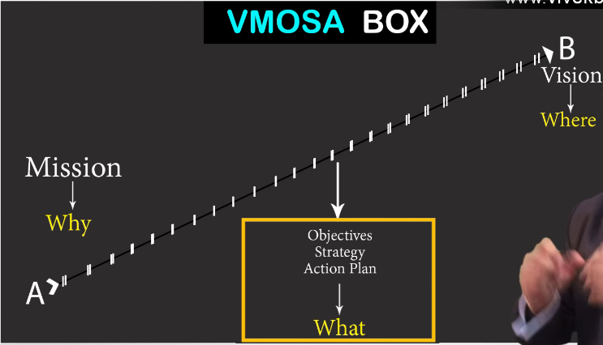

***Objective, Strategy, Action plan***

What you need to do to reach there, Small Steps that take you to your vision, Small Objectives, How will you reach there?

***VALUES (What, Why, When, Where, How)***

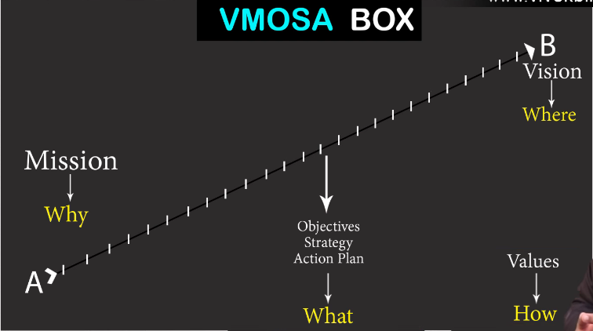

* Core Values (Belief / Behavior)
* How we behave (Core Culture and Nature of how you do things)

***How we are going to behave this always***

* Team Involvement (Set of Behavior)
* Core Values (However great the performer is if Core Values are not practiced is then no use of company)
* Culture of Company (It is set by Core Values, Can bring Magic)
* Clarity is Power

**Profit is outcome not purpose, purpose is your mission that why you want to do it.**